|  |
| --- |
| Preserving Water Quality in the Savannah River |
| Protecting the Future of Drinking Water Supply |
| Eric Krueger1 and Neil Jordan2 1Director of Science and Stewardship; The Nature Conservancy – South Carolina Field Office  2Geographic Information Systems Manager; The Nature Conservancy – South Carolina Field Office |
|  |

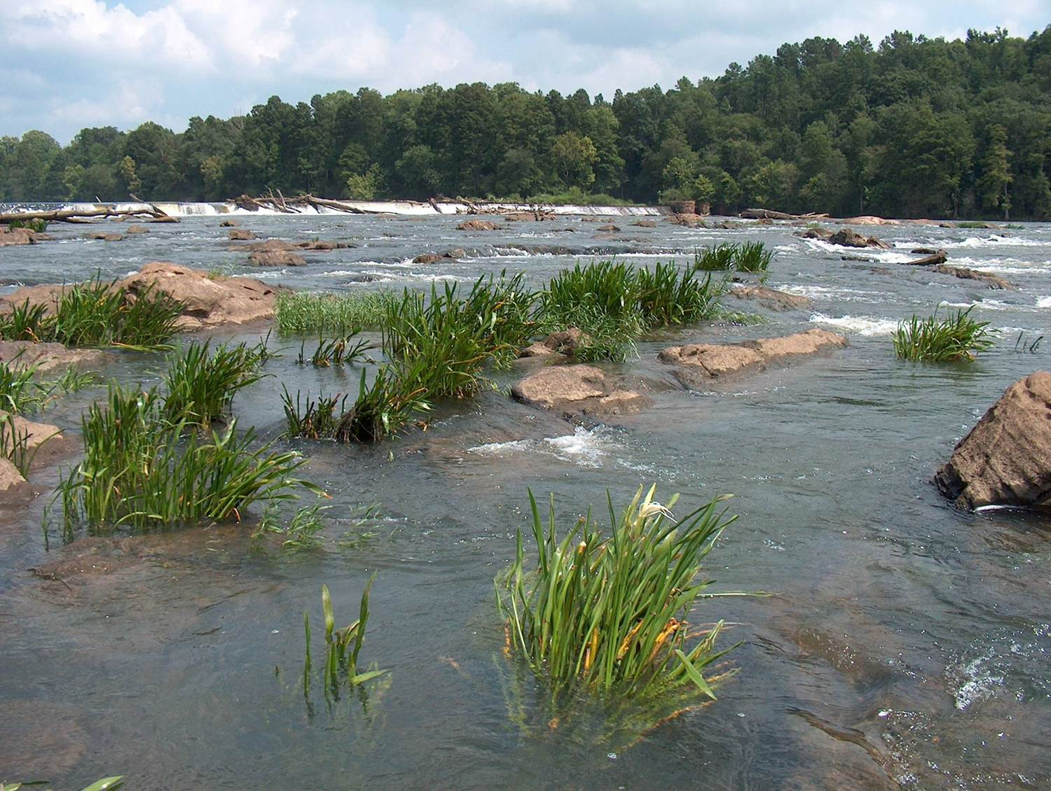

**TABLE OF CONTENTS**

**I. Introduction ….. 2**

**Purpose of This Paper ….. 2**

**Lower Savannah Sub-basin: An Overview ….. 2**

**II. The Case for Watershed Protection ….. 4**

**The Land-Water Relationship ….. 4**

**Water Quality Functions of Natural Lands ….. 6**

**Water Quality in Mixed Land Use Watersheds ….. 7**

**III. Watershed Protection: The Savannah River Opportunity ….. 7**

**Lower Savannah Sub-basin Land Use ….. 8**

**The Primary Threat: Urban Development ….. 10**

**The Coming Threat: Emerging Contaminants ….. 10**

**IV. How Much Protection Does a Watershed Need? ….. 13**

**V. Setting Priorities for the Lower Savannah River Sub-basin ….. 13**

**Setting Priorities: The Watershed Management Priority Index ….. 14**

**Addressing the Threats: A Scenario for 2030 ….. 17**

**VI. Conclusion ….. 19**

**VII. Additional Resources ….. 19**

**VIII. References ….. 20**

**Appendix A: Analysis Methods ….. 23**

**Appendix B: Southeast GAP Land Cover Assignments ….. 28**

**Appendix C: Mixed Land Use Watershed Examples ….. 31**

**Introduction**

This document describes the water quality maintenance services performed by forests and well-managed agricultural lands. Peer-reviewed studies demonstrating these services are described, with links to many additional supporting resources. These water quality principles are then applied to the 2.79M-acre Lower Savannah River sub-basin below Thurmond Dam at Clarks Hill, South Carolina. GIS analysis and a conservation priority model based in these principles are applied to the lower Savannah River sub-basin to create a vision for how land protection in the sub-basin can maintain these services indefinitely.

**Purpose of This Paper**

This paper describes the value of natural lands in providing water quality appropriate for drinking, industry, and recreational enjoyment. These values have been reinforced by innumerable studies. We then apply these principles to lands of the Savannah River watershed. Focusing on the lower Savannah basin below the Fall Line (Figure 1), we describe the current state of the landscape and the opportunity to conserve that landscape. Conserving the landscape will insure that current and future generations have clean, affordable drinking water, and industrial, commercial, and recreational waters that provide quality of life.

**Lower Savannah Sub-basin: An Overview**

Forming the border of Georgia and South Carolina, the Savannah River flows for 301 miles, connecting the Southern Blue Ridge mountains to the Atlantic Ocean. A series of mountain streams and rivers, including the famous Chatooga River, come together in the foothills of the Piedmont. From there, a series of dams and reservoirs provide hydropower, drinking water, and recreational opportunity to thousands of residents in the Southeast. The reservoirs host some of the best largemouth and striped bass fishing known anywhere.

The Clarks Hill / J. Strom Thurmond hydropower facility (fig. 1) regulates flows on the Lower Savannah and the majority of water volume available for human and natural uses. The last dam is at New Savannah Bluff (fig. 1), just downstream of the City of Augusta. The lower Savannah River then flows freely and empties 200 miles later into the Atlantic Ocean, delivering the 3rd largest amount of freshwater to the ocean among the many Atlantic seaboard rivers. Many persons, industries, and plants and animals depend on this water for sustenance. For example, the lower Savannah River provides drinking water to over 475,000 people. In addition, the future growth of the City of Savannah depends on withdrawals from the river, as groundwater resources in the area are now fully allocated. The river also supports the federally endangered shortnose sturgeon, an imperiled sucker known as the robust redhorse, striped bass, and a commercial fishery for American shad.

The natural beauty and values of the Savannah River have inspired a variety of conservation actions over the decades. Between Augusta and Savannah, the River and its 2.1M acre watershed are largely rural, with 78% of the watershed covered by forest land. Over 157,000 acres of this forest is riverine floodplain

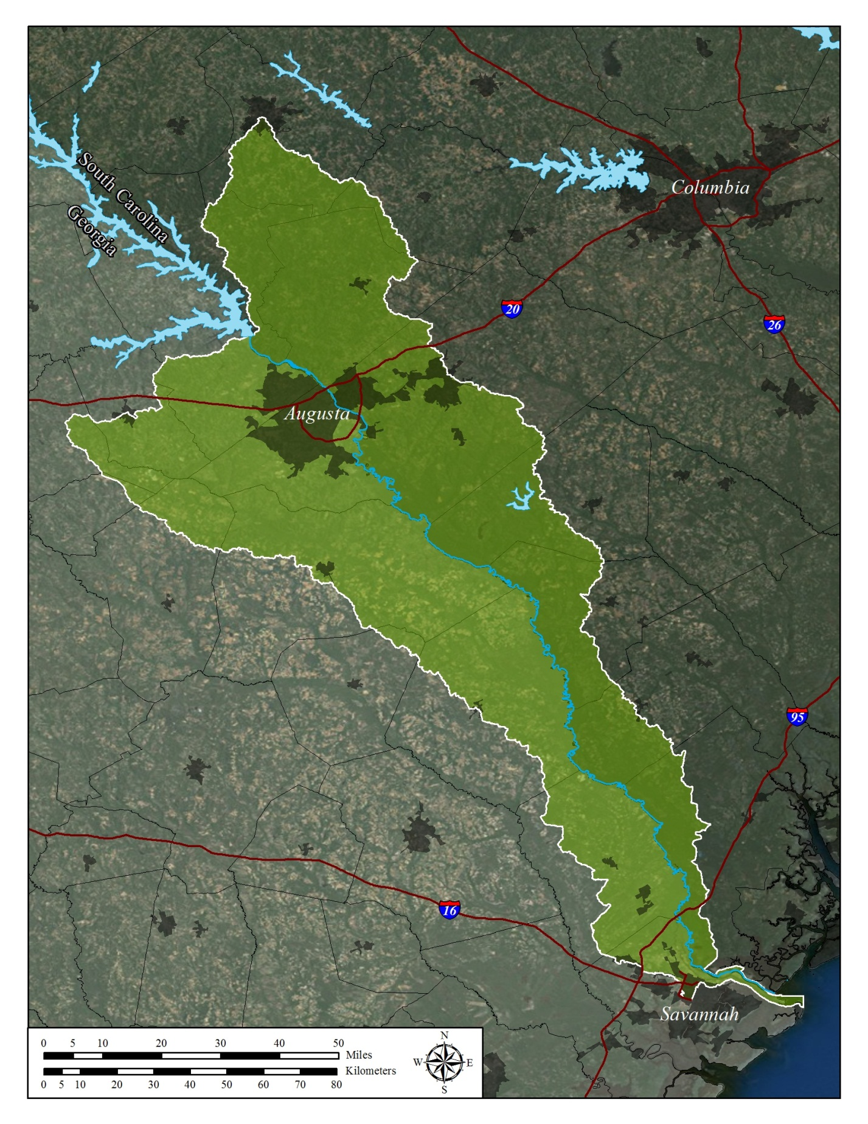Figure 1: The Lower Savannah River Sub-basin including all watersheds downstream of Thurmond Dam

New Savannah Bluff Lock and Dam

J. Strom Thurmond Dam Facility

on the mainstem, providing flood flow retention, nutrient and sediment trapping, and excellent recreational opportunities. Overall, the lower Savannah River basin contains 245,119 acres of land protected by public and private land purchases and conservation easements (Fig. 2). These protected areas capture 101,000 of sensitive floodplain acres. The lower basin also houses the Fort Gordon military base and the Department of Energy’s Savannah River Site. Together, these comprise another 256,881 acres that are likely to retain a primarily natural forested character. (*Note: See Appendix A: Analysis Methods for detail on derivation of landscape metrics*).

The primarily natural character of the Savannah basin is a great example of *green infrastructure* – a network of natural features that provide critical products and services. In this case, products and services include clean air, clean water, fish and wildlife, recreational opportunities, property values, and natural products through commercial fishing, timbering, farming, and other resource-based activities.

**The Case for Watershed Protection**

**The Land-Water Relationship**

The balance of land uses in a watershed is a major driver on water quantity, quality, and flood behavior. The importance of land use is rooted in the critical influence of headwater streams. Headwater streams compose over 75% of the stream mileage in the United States (Leopold, 1956). Headwater streams are the most immediate conduits of non-point source pollution, and their condition is a major determinant of the health and quality of downstream waters (Alexander et al 2007). Yet, these small tributaries are often dismissed as unimportant and exempted from permitting requirements and best management practice manuals. Maintaining natural lands in headwater areas is the most feasible way to assure the health of headwater streams and thus, the health of perennial reaches further downstream.

To some extent, the protection of stream and river habitats and water quality has over-emphasized the retention of riparian buffers, detention ponds, and other best management practices. These are important pieces of overall watershed protection, but they cannot protect water quality in the face of widespread land development. Riparian buffers can fail to overcome the impacts of upslope urbanization (Booth et al., 2002), though they can perform well in agricultural contexts when part of a comprehensive BMP approach (Tomer and Locke, 2011). Studies of streams serviced by stormwater detention ponds have not shown biological and water quality improvements or maintenance (Roy et al., 2008). For all the above reasons, protecting natural water values by protecting the land base is the most comprehensive and lasting measure for watersheds where these values still exist.

A long history of research on forest and water interaction has produced clear relationships of land use to water quality. The following sections describe these key relationships, and refer the reader to additional resources.

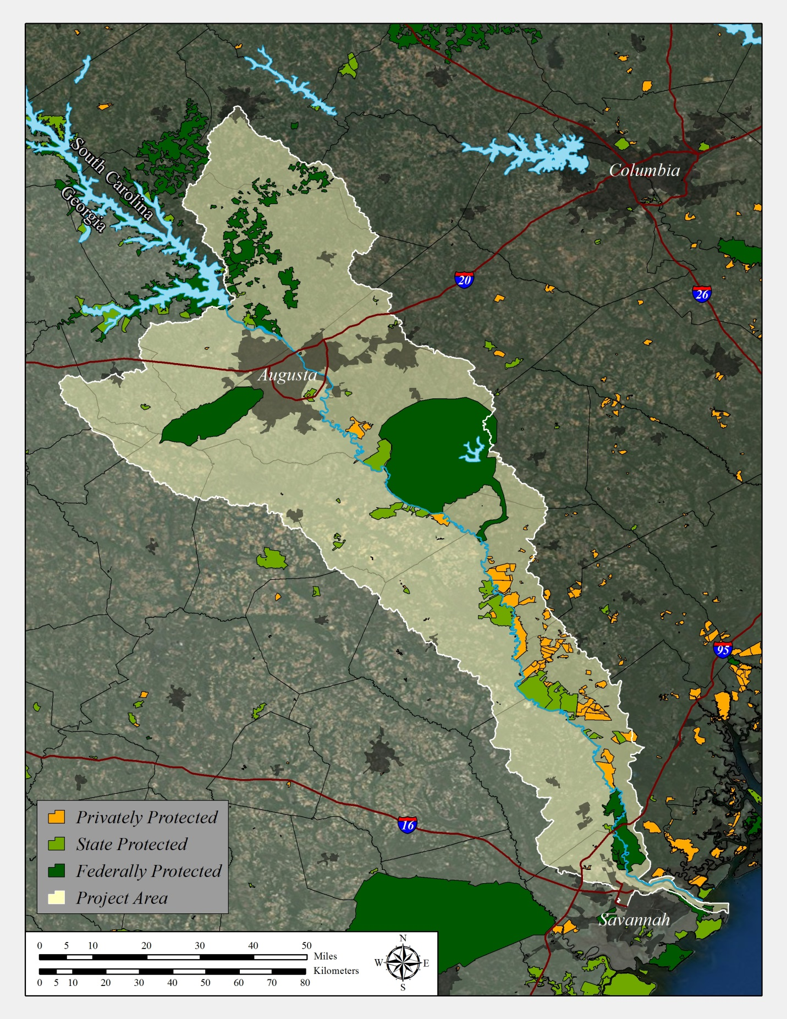Figure 2: Protected lands in the lower Savannah River sub-basin*.*

**Water Quality Functions of Natural Lands**

In the southeastern United States, forest is the predominant natural land type. Forests consistently produce cleaner waters than urban or agricultural lands. The benefits of forest cover to raw water quality have been long-noted and studied in detail, particularly in the United States. The science was institutionalized in the United States in 1927 (Zon, 1927), leading to the formation of 441 experimental watersheds across the nation. Excellent literature compilations can be found in de la Cretaz and Barten (2007), Dissmeyer (2000), and through the Additional Resources section on page 21.

Rainfall moving over the forest floor passes through layers of fallen leaves, root networks and other natural material. Rainfall can also pass through forests as shallow groundwater that moves slowly toward streams through shallow soil layers. These forest floor and soil layers act as filters that remove sediments and contaminants, either from airborne sources or from urban or agricultural areas located upslope. By contrast, urban areas replace these filtering surfaces and layers with hard surfaces that accumulate toxins during dry periods. These are rapidly flushed into streams during rainfalls. Impervious surfaces concentrate rainfall into runoff carrying a wide variety of pollutants from vehicles, asphalt, building materials, lawn fertilizers, and pesticides.

Forest lands are sinks for nutrients and atmospheric pollutants, trapping them before entering streams (Swank and Douglass, 1977; Likens and Bormann, 1995). For example, the Table Rock watershed near Greenville, SC, is nearly 100% forested, and water quality there has remained unchanged since 1930 (Okun, 1992). Schoonover and Locakby (2006) found an urban watershed (24% impervious surface) produced 2-4x more nitrate, chloride, and sulfate than a forested reference watershed (<5% impervious surface) in the Georgia Piedmont. Paired urban-forest watershed studies in the Coastal Plain of South Carolina also show elevated nutrient and ion levels in urban watersheds versus forested references (Wahl et al 1997; Tufford et al 2003). In the Florida Gulf Coast, sediment, temperature, nutrients, chloride, and bacterial levels were all elevated in an urbanized watershed versus a forested reference (Nagy, et al 2012). Most of these researchers also found that forests export more organic carbon to streams than urban areas, an important basis for stream life at all levels (Vannote et al 1980).

Forest lands also prevent sedimentation to streams (Jackson et al 2004), and consistently produce lower turbidity and suspended solid loads. The effect of forest sediment retention has been documented in various settings of the United States. Suspended solids were 4-5 times greater in urban versus forested watersheds in the Southern Appalachians (Clinton and Vose, 2006), 2 times greater in Georgia Piedmont settings (Schoonover et al 2005, Crim 2007), and 2 times greater in Coastal Plain streams of South Carolina (Wahl et al 1997). Increased sedimentation in urban streams is a combined effect of vegetation removal and increased impervious surface, which creates flash flow and channel erosion in addition to overland erosion (Lenat and Crawford 1994, Paul and Meyer 2001, Schoonover et al 2005, Clinton and Vose 2005). This combination of causes and effects has been replicated in research throughout the world, and has given rise to the term *urban stream syndrome* (Walsh et al 2005).

Forests are also effective at trapping pesticides, metals, and other toxic compounds that may originate from adjacent urban or agricultural lands. Many toxic compounds adsorb to sediments, which forests trap very efficiently. Mixed buffers of grass, managed pine, and natural hardwoods averaging 150 feet wide were effective in trapping atrazine and alachlor in south Georgia (Lowrance et al 1997). A review of southeastern US studies on forest buffer – pesticide interactions by Neary et al (1993) found that water quality violations occurred only when chemicals were applied in the buffers themselves. Forest buffers have also proven effective at removing metal contaminants (Groffman et al, 1991; Herson-Jones et al. 1995).

**Water Quality in Mixed Land Use Watersheds**

The best raw water quality may originate from forests, but virtually all major watersheds of the United States contain mixed land uses, including the Savannah River. Complete forest or natural land cover is rare, and some amount of urban and agricultural area is typically present. The resultant water quality in streams from mixed use watersheds can still be excellent depending on the balance of land uses, landscape position of non-forest activities, the specific land use activities, and use of best management practices. For example, a corn field plowed to the edge of a stream and heavily applied with herbicide and fertilizer will have a much greater impact on water quality than a rotational grazing system fenced and buffered from the stream by a forest or natural grassland strip, though both would be generally classified as agriculture.

Numerous studies support the efficacy of agricultural best management practices at the field or stream reach scale (see Tomer and Locke, 2011, and references), but watershed-scale monitoring of BMP application and water quality output of mixed land uses has been less frequent. The NRCS is addressing this gap, leading a multi-agency effort known as the Conservation Effects Assessment Project (CEAP). Initiated in 2002, the Project is quantifying the effects of conservation practices at national, regional, and watershed scales and includes croplands, grazing lands, wetlands, wildlife effects, and the socioeconomic factors that lead landowners to select or decline participation in practices. Thirty-seven (37) watershed studies are currently in progress under CEAP, covering most major agricultural production regions and practices. In some cases, the watersheds contain over 30 years of continuous monitoring data collected by the Agricultural Research Service prior to the Project’s formation.

A number of watershed-scale research efforts have documented the water quality outputs of watersheds with mixed forest and agricultural land uses. See Appendix C: Mixed Land Use Watershed Examples for case studies and references.

**Watershed Protection: The Savannah River Opportunity**

Forested lands clearly provide excellent water quality, and mitigate potential impacts from adjacent or upstream non-forest land uses. Well-managed agricultural lands can also sustain good raw water quality, particularly when upland BMPs are coupled with natural riparian buffers. The lower Savannah River sub-basin provides extensive forest cover, modest extents of agricultural and urban lands, and delivers very good raw water quality. The following sections detail current conditions, and provide an approach for maintaining these conditions into the future.

**Lower Savannah Sub-Basin Land Use**

Currently, the Lower Savannah Sub-basin is largely forested and rural (Figure 3). The current land use distribution was analyzed in GIS using land cover data from 2006 satellite imagery, and is detailed in Table 1. From a water quality standpoint, the Lower Savannah Sub-basin benefits from several factors that, if maintained, will assure good raw water quality into the indefinite future. These are:

1. The preponderance of forested land use in the sub-basin. At 78% of total area (2.16M acres), these forests slow the transit of rainfall to the river, providing cleansing through shallow soil pathways for water movement. The interception of rainfall by tree canopies also prevents flash flooding, a mechanism that erodes stream channels and degrades water quality and habitat.
2. The relatively low percentage of urban development at this point in time (2014). Urban areas have a disproportionate impact on water quality by accumulating many non-point source contaminants from vehicles, fueling stations, parking lots and other sources, and distributing these into streams in flash floods exacerbated by impervious surfaces. Urban areas are also the primary source of emerging contaminants (see Page 12). At 8.9% of the total area (247,000 acres), urban area in the sub-basin is not insignificant, but likely remains below thresholds for water quality degradation and the onset of flash flooding effects.
3. The retention effect of the major reservoirs on the Savannah River. Irrespective of any other impacts, reservoirs perform a simple function of trapping sediments and non-point source inputs from the more-developed sub-basin upstream in the Piedmont. Many contaminants are attracted to sediments, so this trapping function also retains many urban pollutants such as oil and grease, heavy metals, and fire retardant and construction material residues. Runoff from the Augusta and North Augusta urban areas are retained within the pond behind New Savannah Bluff Lock and Dam, which likely performs some additional non-point pollutant retention.



Table 1: Land cover distribution of the Lower Savannah Sub-basin, based on 2006 satellite imagery. The analysis boundary is all basin area that inflows downstream of Thurmond Dam (see Figure 1).

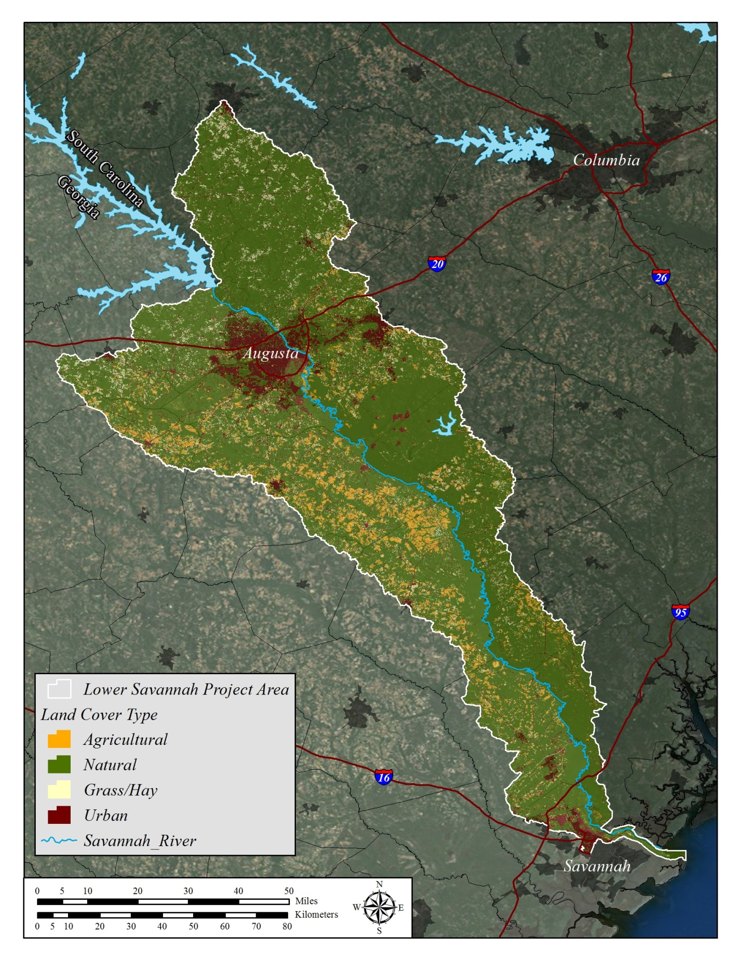

Figure 3: The distribution of land uses in the lower Savannah River sub-basin (2006 Southeast GAP).

**The Primary Threat: Urban Development**

Development within the Lower Savannah Sub-basin is a case of two ends driving toward the middle, with Augusta and North Augusta expanding on the upstream end, and Savannah and Hardeeville on the downstream end. While Augusta proper has seen a slight decline in population from 2000-06, the overall population of the Augusta-Aiken Metropolitan Statistical Area (MSA) increased by 4.72% over the same period (US Census 2010). The population of Savannah, GA, grew by 9.22% over the same period. Substantial expansion of urban and suburban area is already planned for Hardeeville, creating the largest incorporated area in South Carolina. Once land is developed, reversal is not feasible, and future generations will bear the burden of these environmental and economic costs.

A substantial portion of urban development is gradual, and occurs in disparate areas well removed from incorporated cities. Large lot housing and rural sprawl may not be as readily apparent as compared to high-density urban expansion, but continues to convert natural lands with attendant hard surfaces, and introduction of chemical contaminants onto the land base. Figure 4 displays the land use of the lower sub-basin downstream of US Highway 301 in 1970 compared to 2030. While true urban area is projected to grow only slightly, a substantial portion of the landscape will convert to exurban housing with its hard surfaces, vegetation clearing, and increases in pet fecal matter, chemical use, and other land base changes that degrade water quality and increase downstream flood risks.

**The Coming Threat: Emerging Contaminants**

The National Pollution Discharge Elimination System (NPDES) and Safe Drinking Water Act have done much to assure safe natural and potable waters for people and nature in the United States. However, society is proliferating an increasing number of manufactured chemicals that were not envisioned at all when the Clean Water Act was passed. Many of these chemicals are common household products, prescription and non-prescription medicines, human and veterinary hormones, and antibiotics. Many of these compounds are not removed by typical water treatment processes.

In a study of 139 streams in 30 states from 1999-2000, the US Geological Survey discovered a broad range of chemicals in 80% of the sampled streams (Buxton and Kolpin, 2002). These chemicals include human and veterinary drugs (including antibiotics), hormones, detergents, disinfectants, plasticizers, fire retardants, insecticides, and antioxidants. These were often found as mixtures, with 75% of streams with findings containing more than one contaminant.

This and other studies have triggered new concerns and research on the extent, effects, and interactions of these contaminants, and how water treatment processes affect or potentially transform them. Some concerns include endocrine disruption in humans and wildlife, and developing resistant pathogens from long-term, low level exposure to antibiotics and anti-viral drugs like Tamiflu. In 2006, the state of Massachusetts passed water treatment requirements for perchlorate, an endocrine disruptor found in munitions and fireworks, and California followed suit in 2007 (Charnley, 2008).

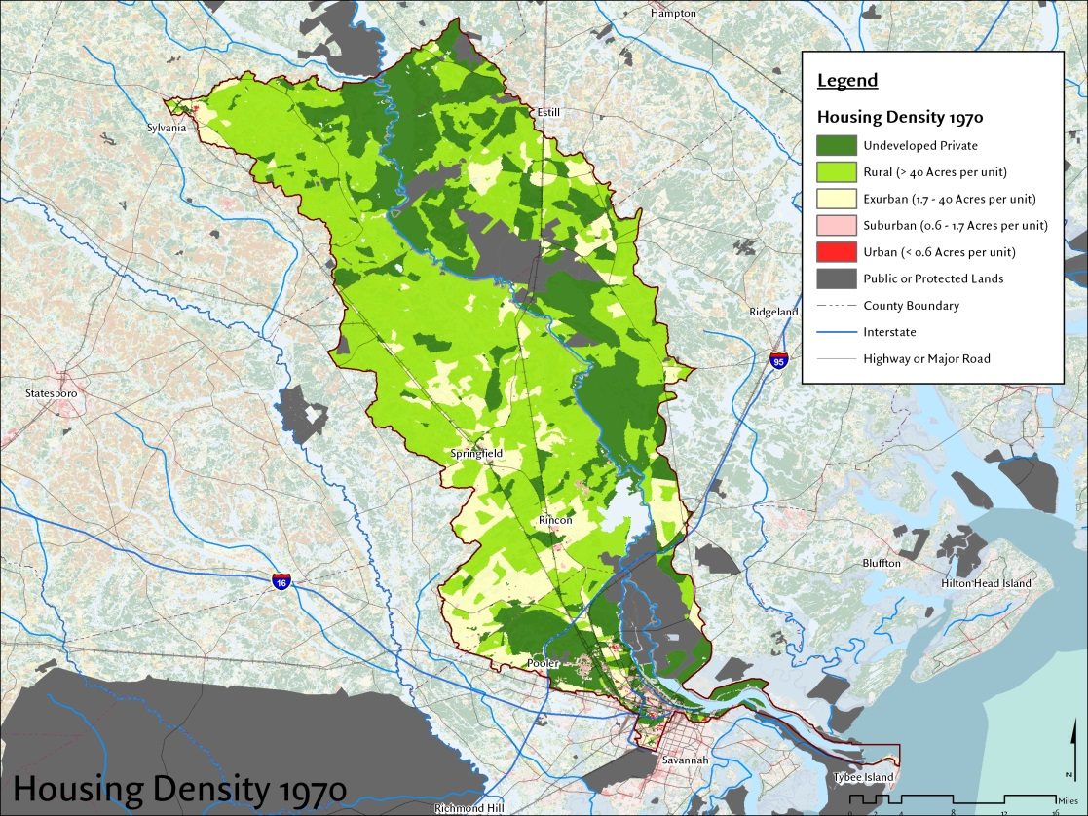

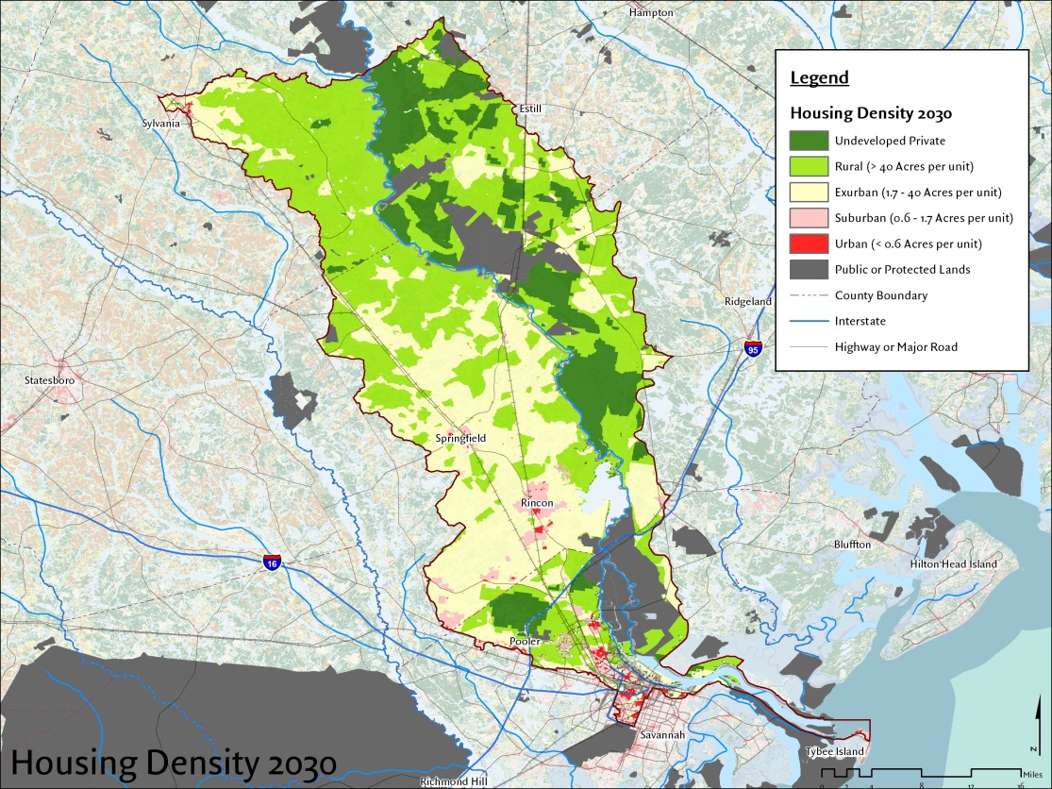

Figure 4: Substantial increases in large-lot housing (exurban development) are projected for the lower Savannah River sub-basin by 2030. The upstream boundary is the edge of hydrologic units immediately downstream of US Highway 301, and is approximately 2 days travel time from municipal water intakes downstream.

The Massachusetts perchlorate example clearly demonstrates the possibility for one or more of these contaminants to trigger new regulatory and costly new treatment requirements. This is yet another risk that can be reduced with watershed land protection. Constraining the urban footprint in the watershed could have the following benefits with respect to emerging contaminants:

1. Less urban growth will reduce nonpoint runoff of emerging contaminants from construction sites, which are sources of paint pigments, fire retardants, and many other chemicals associated with new construction materials
2. Constraining urban growth to a smaller footprint increases the practicality of servicing new developments with water and sewer infrastructure. Contaminants captured in the wastewater system can be treated, whereas contaminants arising from dispersed septic systems will be more difficult to address.
3. Reducing emerging contaminant inputs from a combination of point- and nonpoint controls reduces the likelihood that a regulatory limit would be triggered.

A watershed protection approach may not eliminate emerging contaminants, but will help to keep their concentrations at the most minimal levels possible. Savannah basin users will stand a better chance of remaining under treatment levels, even if treatment requirements arise to address emerging contaminants.

**How Much Protection does a Watershed Need?**

Fully protected watersheds like those in Greenville, SC; Cedar Creek, WA and Bull Run in OR have demonstrated how natural forest lands provide reliably clean raw water supplies. Fortunately though, a watershed does not have to be 100% forested or protected to provide good raw water quality. A study of 27 water suppliers by Ernst et al (2004) demonstrated that the forest-water relationship exists as a continuum, with greater forest percentages in upstream watersheds producing lower water treatment costs. Overall, 55% of treatment cost was explained by upstream forest cover (Figure 5).

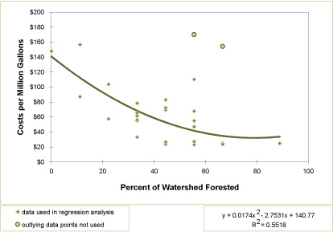

Figure 5: The relationship of upstream watershed forest cover and water treatment costs (from Ernst et al 2004).

This relationship suggests that the lower Savannah River sub-basin delivers water at the lower end of the treatment cost curve. The curve also implies that the sub-basin can support a balance of other land uses *and* good water quality, as long as a preponderance of watershed forest cover is maintained.

**Setting Priorities for Watershed Protection in the Lower Savannah Sub-basin**

The Lower Savannah Sub-basin is at a critical juncture. Forested extent is still sufficient to positively affect raw water quality. Development pressures have not accumulated to where land protection at a scale sufficient to protect water quality is cost-prohibitive. Extensive watershed science and practical experience assures us that land protection is a sound measure to protect water quality.

Yet, the Lower Savannah Sub-basin is a very large area at 2.79M acres. A 60% forest retention goal computes to a 1.67M acre overall watershed protection goal. With 502,000 acres currently secure as forest, an additional 1.17M acres must be secured to meet the goal. At bargain easement rates of $200 per acre, that represents a $334M investment. This may materialize over a long period of time, but in the shorter term, there is a clear need for prioritization of conservation transactions. Fortunately, not all natural and rural land areas are created equal in terms of their contribution to raw water quality, and priorities can be determined and made geographically explicit. Differences in soil characteristics, slope, distance to water features, and other factors produce differences in the degree of threat to water quality, should that particular land area be developed.

To identify these differences, we have employed a tool called the Watershed Management Priority Index (WMPI). The Index uses detailed land cover, soil, and elevation data to identify the highest priority areas for water quality maintenance (Randhir et al, 2001; Zhang, 2006; see Appendix A for details on the WMPI application and data sets used).

**Setting Priorities: The Watershed Management Priority Index**

As early as 2009, we recognized the need to make an explicit connection between the land resources of the Savannah Basin, and their impact on raw water supplies. An initial technical committee was formed in 2009 to discuss approaches to land prioritization for water quality. An analysis area was agreed upon, capturing the basin downstream of Thurmond Dam. In 2010, an outreach workshop was conducted with municipal suppliers and regulators working in that area. In reviewing several potential modeling approaches in the workshop, the WMPI was selected as the best fit for the scale and issues of interest in the water supply community. Over the remainder of 2010 and 2011, The Nature Conservancy gathered the necessary data and conducted the modeling, with external review points along the way.

The Watershed Management Priority Index (WMPI) is a GIS-based tool that allows users to analyze and layer landscape factors that affect water quality. The WMPI contains three sub-modules: the Conservation Priority Index (CPI), the Restoration Priority Index (RPI), and the Stormwater Management Priority Index (SMPI). As the lower Savannah River sub-basin is 78% forested, we assume that conservation of existing forest is a priority for water quality. Targeting of existing natural lands is best represented by the CPI, as it prioritizes natural areas with soil and landscape factors that, if protected, will best preserve existing water quality.

The WMPI is best thought of as a representation of how readily land conversion and human activities at any point on the ground will translate to the stream and river system. Construction or impervious surfaces in the floodplain or stream corridors will have immediate negative consequences to water quality. These activities will also have negative consequences on sites away from streams but on slopes or areas with low soil infiltration potential, where runoff forms readily. The same activities on gentle slopes, high infiltration soils, and well removed from streams will have much less impact. The WMPI cannot be used to project a specific amount of contamination that may occur, or the specific nature of chemical constituents or dissolved oxygen demands that may result from activities in particular places. Such projections would require much more specific information and study at the site level.

Figure 6 shows the results of the CPI sub-module applied to the lower Savannah basin. Clear differences emerge from one landscape position to another. The river corridors emerge as high priority areas due to their proximity to receiving waters. However, there are many areas away from rivers and streams whose soil characteristics, slope or other conditions make them important as well. Careful examination of Figure 6 reveals many priority land areas that lie outside of stream corridors. These areas are unlikely to be identified as important areas for water quality absent this type of analysis.

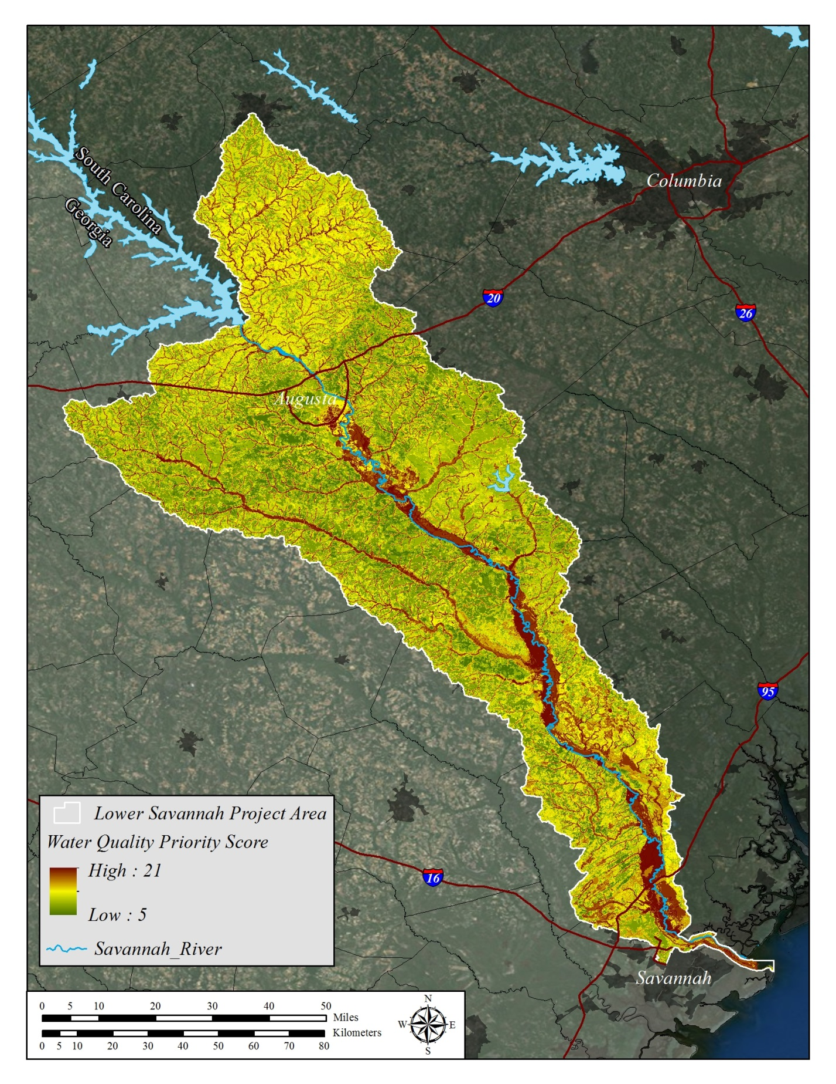

Figure 6: Results of the Conservation Priority module of the Watershed Management Priority Index for the lower Savannah River sub-basin

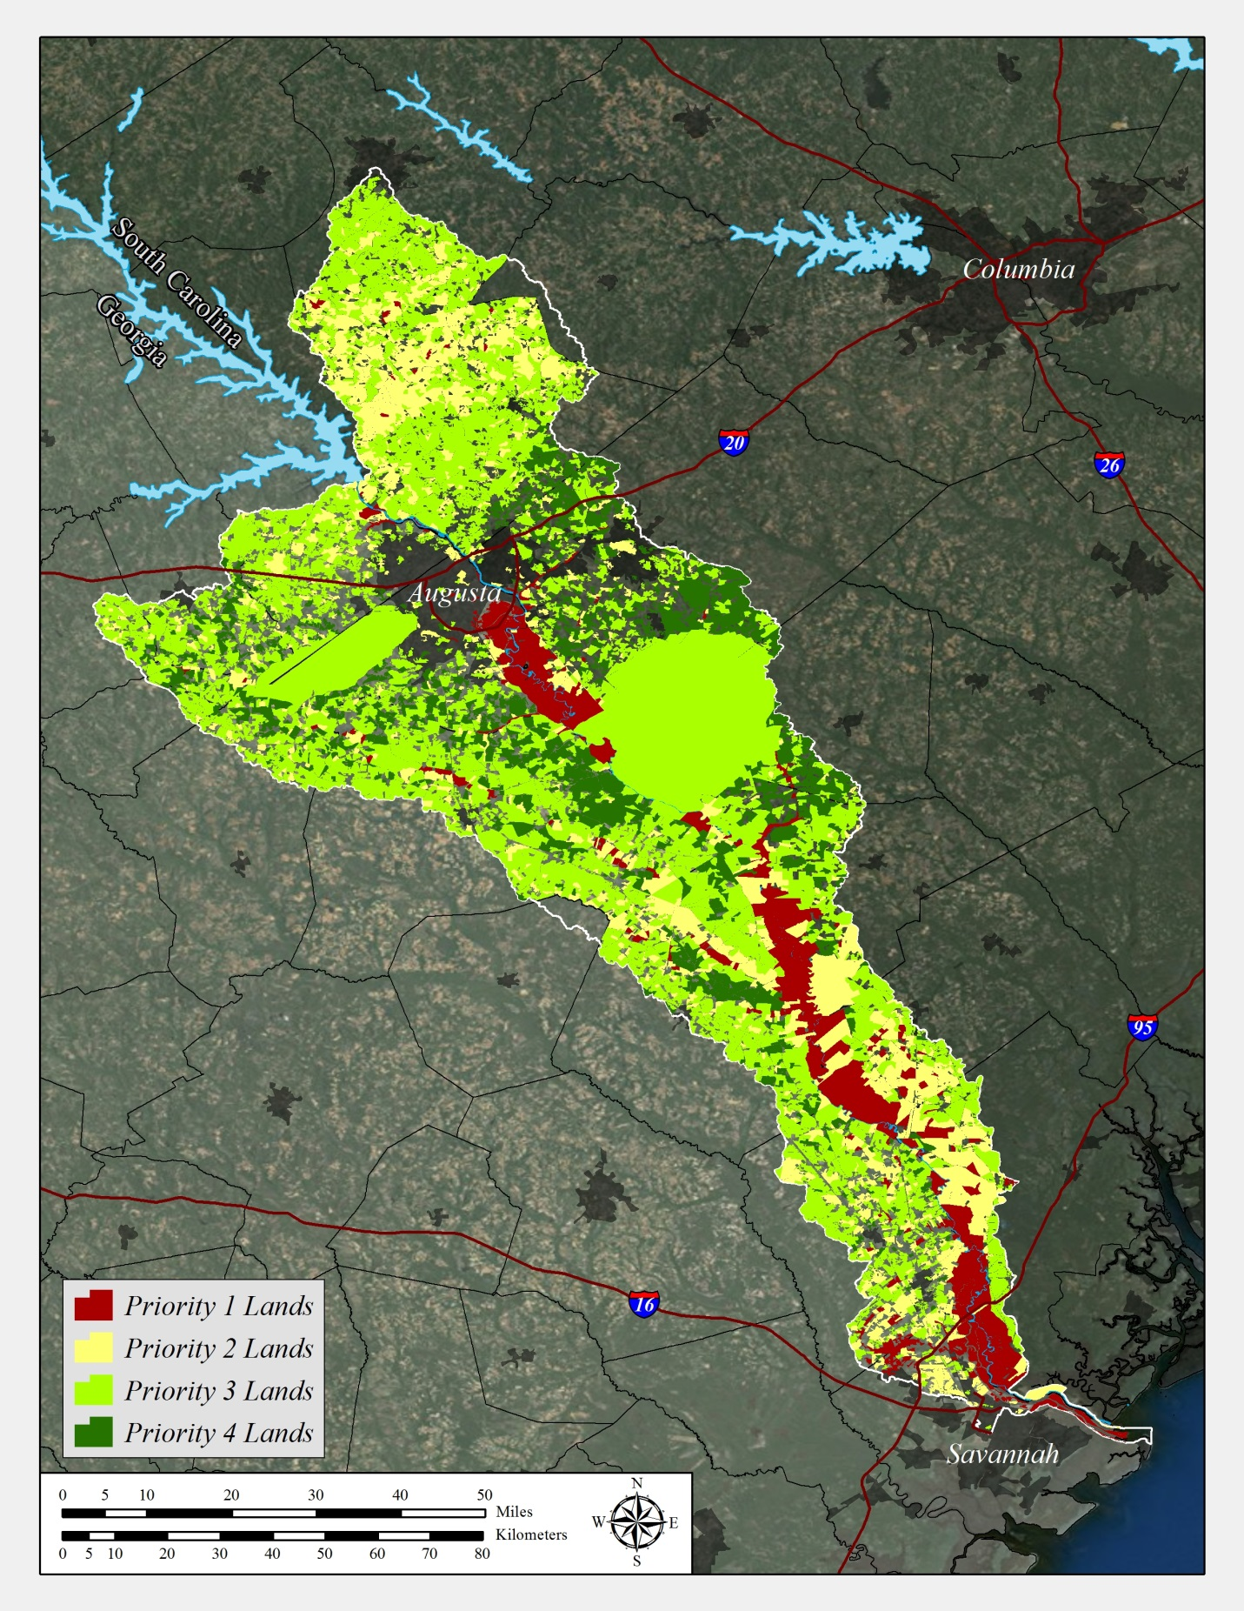

Figure 7: Results of the CPI, normalized to legal tract boundaries of 100 acres or more. A gap is present for Saluda County, SC, and Jenkins County, GA due to lack of digital tract data for those counties.

The CPI results portrayed at a landscape scale are not useful for actual watershed protection, which proceeds within legal tract boundaries and landowner transactions. To clarify the importance of individual tracts, the results of Figure 6 were integrated within legal tract boundaries. CPI scores were summed within tracts and divided by acreage to produce a single tract score. Scores ranged from 5-14 for all tracts over 100 acres. Scores were then clustered into four natural classes, and each class was assigned a priority level 1-4. This provides a mechanism to rank individual tracts on their relevance to raw water quality. These results are shown in Figure 7. Again, river corridor properties constitute obvious targets, but there are also many non-riparian properties with high water quality scores.

**Addressing the Threats: A Scenario for 2030**

Figure 3 (p. 11) projected how urbanization may proceed in the lower Savannah River sub-basin, with a focus downstream of US301. In Figure 8, we present a scenario to illustrate the landscape downstream of US301 if all Priority 1 and 2 parcels were protected by 2030.

The sub-basin area below US301 is 598,469 acres with 142,471 acres of currently protected lands that are nearly 100% forest (24% of the scenario area). Protecting all Priority 1 lands below US301 would increase protected area by 58,859 acres, raising permanent natural cover to 34% of the area. Adding Priority 2 lands would increase protected area by an additional 143,132 acres, raising permanent natural cover to 58% of the scenario area.

Notably, this degree of watershed protection can be attained while still allowing ample opportunities for growth. Also, the total acreage (201,991 ac) is on a similar scale of current protected lands, of which ~70,000 acres have been accumulated only since 2005. Protecting these lands could also have the effect of concentrating growth, simplifying the distribution of water infrastructure such that wastewater and emerging contaminants could be contained within water and sewer systems. This would be preferable to diffuse distribution of contaminants through many dispersed septic systems.

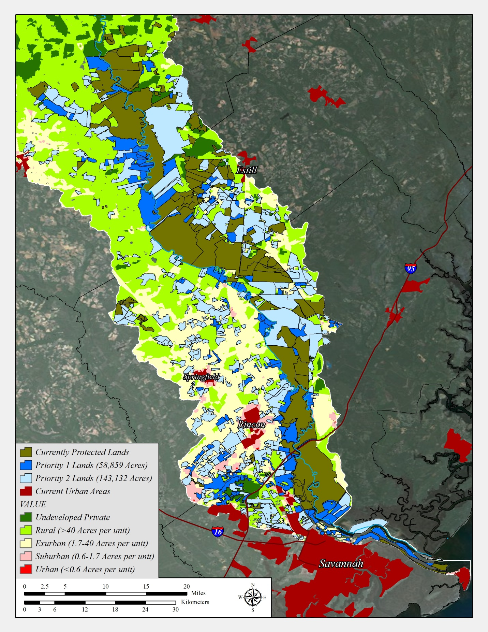

US 301

Figure 8: A 2030 scenario downstream of US 301 with Priority 1 and 2 lands overlain on projected urban / suburban growth.

**Conclusion**

With the lower Savannah basin still containing 77.6% forest cover, there is a clear opportunity to preserve raw water quality, while still maintaining a substantial level of development options for local communities and citizens. *Savannah River Clean Water Fund* has adopted a goal of retaining 60% of the watershed in forest cover to preserve water quality. The number was selected as one that will assure raw water quality while reflecting the reality that some lands will convert to other uses.

There is still time to protect the rural landscape that maintains the water quality essential to so many human and natural community needs. Once development pressures become apparent by casual observation, land values are typically out of reach of conservation funding vehicles. Landowners who may have been amenable to a conservation transaction at one time may now desire a higher return, or wish to vacate the area ahead of coming urbanization. The time to begin a watershed protection effort is ahead of these events while there is time to collate the funding and transactions to be successful, and the accessible tracts are of an extent to make a difference to water quality. That time is now.

**Additional Resources**

There is a substantial body of watershed research demonstrating the benefits that forests deliver for water quantity, quality, and flood peak reduction. See the following resources for reports, and many links and references to this research:

1. Forests for Watersheds, a partnership of the Center for Watershed Protection and the United States Department of Agriculture ([www.forestsforwatersheds.org](http://www.forestsforwatersheds.org))
2. Forest to Faucet, a partnership of the University of Massachusetts – Amherst and the United States Forest Service ([www.forest-to-faucet.org](http://www.forest-to-faucet.org))
3. Southern Forest Futures Project, a comprehensive analysis of southern forests, including water quality and quantity issues beginning in Chapter 13 (<http://www.srs.fs.usda.gov/futures/reports/draft/Frame.htm>)
4. Hydrologic Effects of a Changing Forest Landscape, a National Research Council review of forest hydrology findings from 1976 to 2008. The free download requires the creation of a login and password. (<http://www.nap.edu/catalog.php?record_id=12223>)
5. Conservation Effects Assessment Project, a comprehensive multi-partner program to evaluate agricultural BMP efficacy at multiple scales across the United States (<http://www.nrcs.usda.gov/wps/portal/nrcs/main/national/technical/nra/ceap/>)
6. Soil and Water Conservation Society Publications, a collection of resource management publications, with excellent literature reviews and links (<http://www.swcs.org/en/publications/>)
7. Lake Champlain Basin Program, a collection of agricultural BMP studies at multiple scales with literature reviews and links ([www.lcbp.org](http://www.lcbp.org))
8. Chesapeake Bay Program, an extensive collection of studies focused on land use and water quality within the Bay, with links and references to other regions ([www.chesapeakebay.net](http://www.chesapeakebay.net))

**REFERENCES**

Alexander, R. B., Boyer, E. W., Smith, R. A., Schwarz, G. E., & Moore, R. B. (2007). The role of headwater streams in downstream water quality. JAWRA Journal of the American Water Resources Association, 43(1), 41-59.

Booth, D. B., Hartley, D., & Jackson, R. (2002). Forest cover, impervious surface area, and the mitigation of stormwater impacts. JAWRA Journal of the American Water Resources Association,38(3), 835-845.

Buxton, H. T., & Kolpin, D. W. (2002). Pharmaceuticals, hormones, and other organic wastewater contaminants in US streams: US Geological Survey Fact Sheet FS-027-02, 2 p.

Charnley, G. (2008). Perchlorate: overview of risks and regulation. Food and chemical toxicology, 46(7), 2307-2315.

Clinton, B.D.; Vose, J.M. 2006. Variation in stream water quality in an urban headwater stream in the Southern Appalachians. Water, Air, and Soil Pollution. 169: 331–353.

Crim, J. F. 2007. Water quality changes across an urban-rural land use gradient in streams of the west Georgia piedmont. Auburn, AL: Auburn University. 130 p. M.S. thesis.

De la Cretaz, A.L.; Barten, P.K. 2007. Land use effects on streamflow and water quality in the Northeastern United States. New York: CRC Press. 319 p.

Dissmeyer, G. E. (2000). Drinking water from forests and grasslands. USDA Forest Service General Technical Report SRS-39, Asheville, North Carolina.

Ernst, C., Hopper, K., & Summers, D. (2004). Protecting the source: Land conservation and the future of America's drinking water. Trust for Public Land.

ESRI, 2006. Arcgis (V. 9.2). Environmental Systems Research Institute, Inc., Redlands, CA.

Groffman, P. M., A. J. Gold, T. P. Husband, R. C. Simmons, W. R. Eddleman. 1991b. An Investigation Into Multiple Uses of Vegetated Buffer Strips. Kingston, RI: University of Rhode Island.

Herson-Jones, L. M., M. Heraty and B.Jordan. 1995. Riparian Buffer Strategies for Urban Watersheds. Washington, DC: Metropolitan Washington Council of Governments.

Jackson, C.R.; Sun, G.; Amatya, D.M. [and others]. 2004. Fifty years of forest hydrology in the Southeast. In: Ice, G.G.; Stednick, J.D., eds. A century of forest and wildland watershed lessons. Bethesda, MD: Society of American Foresters: 33–112.

Lenat, D.R.; Crawford, J.K. 1994. Effects of land use on water quality and aquatic biota of three North Carolina Piedmont streams. Hydrobiologia. 294: 185–199.

Likens, G. E. and F. H. Bormann. 1995. Biogeochemistry of a forested ecosystem, 2nd edition. New York: Springer-Verlag, 159 p.

Lowrance, R., Vellidis, G., Wauchope, R. D., Gay, P., & Bosch, D. D. (1997). Herbicide transport in a managed riparian forest buffer system. Transactions of the ASAE, 40(4), 1047-1057.

Meals, D. W. (1996). Watershed-scale response to agricultural diffuse pollution control programs in Vermont, USA. Water Science and Technology, 33(4), 197-204.

Meals, D. W. (2001). Water quality response to riparian restoration in an agricultural watershed in Vermont, USA. Water Science & Technology, 43(5), 175-182.

Meals, D. W., & Budd, L. F. (1998). Lake Champlain Basin nonpoint source phosphorous assessment. JAWRA Journal of the American Water Resources Association, 34(2), 251-265.

Nagy, C. R., Graeme Lockaby, B., Kalin, L., & Anderson, C. (2012). Effects of urbanization on stream hydrology and water quality: the Florida Gulf Coast. Hydrological Processes, 26(13), 2019-2030.

Neary, D. G., Bush, P. B., & Michael, J. L. (1993). Fate, dissipation and environmental effects of pesticides in southern forests: A review of a decade of research progress. Environmental Toxicology and Chemistry, 12(3), 411-428.

Okun, D. A. 1992. Properties of the Table Rock and Poinsett Reservoirs: their future. A report to the Greenville Watersheds Study Committee, P.O. Box 728, Greenville, SC. 24 p.

Paul, M.J.; Meyer, J.L. 2001. Streams in the urban landscape. Annual Review of Ecology, Evolution, and Systematics. 32: 333–365.

Randhir, T. O., O’Connor, R., Penner, P. R., & Goodwin, D. W. (2001). A watershed-based land prioritization model for water supply protection. Forest ecology and management, 143(1), 47-56.

Roy, A. H., Wenger, S. J., Fletcher, T. D., Walsh, C. J., Ladson, A. R., Shuster, W. D., Thurston, H.W., and Brown, R. R. (2008). Impediments and solutions to sustainable, watershed-scale urban stormwater management: lessons from Australia and the United States. Environmental management, 42(2), 344-359.

Schoonover, J.E.; Lockaby, B.G.; Helms, B.S. 2006. Impacts of land cover on stream hydrology in the west Georgia Piedmont, USA. Journal of Environmental Quality. 35: 2123–2131.

Schoonover, J.E.; Lockaby, B.G.; Pan, S. 2005. Changes in chemical and physical properties of stream water across an urban-rural gradient in western Georgia. Urban Ecosystems. 8: 107–124.

Swank, W.T.; Douglass, J.E. 1977. Nutrient budgets for undisturbed and manipulated hardwood forest ecosystems in the mountains of North Carolina. In: Correll, D.L., ed. Watershed research in Eastern North America. Edgewater, MD: Smithsonian Institute: 343-362. Vol. 1.

Tufford, D.L., Samarghitan, C.L., McKellar, H.N., Jr. [and others]. 2003. Impacts of urbanization on nutrient concentrations in small southeastern coastal stream. Journal of the American Water Resources Association. 39(2): 301–312.

Vannote, R. L., Minshall, G. W., Cummins, K. W., Sedell, J. R., & Cushing, C. E. (1980). The river continuum concept. Canadian journal of fisheries and aquatic sciences, 37(1), 130-137.

Wahl, M.H.; McKellar, H.N.; Williams, T.M. 1997. Patterns of nutrient loading in forested and urbanized coastal streams. Journal of Experimental Marine Biology and Ecology. 213: 111–131.

Walsh, C. J., Roy, A. H., Feminella, J. W., Cottingham, P. D., Groffman, P. M., & Morgan II, R. P., 2005. The urban stream syndrome: current knowledge and the search for a cure. J. N. Am. Benthol. Soc. 24(3): 706-723.

Wenger, S. (1999). A review of the scientific literature on riparian buffer width, extent and vegetation. Institute of Ecology; University of Georgia, Athens, GA, 59 pp.

Zhang, Yanli., 2006. Development and Testing of a Watershed Forest Management Information System. Version 1.0, Ph.D. Dissertation, University of Massachusetts, Department of Natural Resources Conservation.

Zon, R. (1927). Forests and water in the light of scientific investigation. USDA Forest Service, Washington, D.C. Senate Document 469, 62nd Congress, 2nd Session.

**APPENDIX A: Analysis Methods**

Geographic Information Systems (GIS) was used to develop basic sub-basin land use statistics and the Watershed Management Priority Index (WMPI). All work was conducted in ArcMap 10.0, Build 2414. All inputs were either acquired in, or projected to NAD83, UTM Zone 17N. All outputs are in that projection. The following describes the process, data layers, model weightings, and decisions made to produce the outputs.

**Project Area Boundary**

The project area boundary was selected by a committee composed of staff from the City of Savannah, Beaufort-Jasper Water and Sewer Authority, GA Division of Environmental Protection, GA Division of Forestry, SC Department of Natural Resources, SC Department of Health and Environmental Control and The Nature Conservancy. The committee selected all 12-digit Hydrologic Unit Codes that drained into the Savannah River below Thurmond Dam, as water released from the Dam is of excellent quality with respect to municipal and industrial use. This produced a project area boundary that spans 2,797,255 acres. All maps and WMPI outputs reside within this boundary. The boundary is herein described as the *lower Savannah River sub-basin*.

**Land Use Statistics**

Land use statistics were derived from the Southeast Gap Land Cover data of 2006, using the full southeast US coverage located here: <http://www.basic.ncsu.edu/segap/index.html> The Southeast Gap data contains 195 vegetation associations, not all of which are found in the lower Savannah sub-basin. NatureServe Associations that occur in the Savannah watershed were identified through NatureServe association descriptions sorted by geographic attributions, along with best professional judgment. Associations were grouped into general cover classifications of natural (all natural vegetation associations plus evergreen plantations), semipermanent (haylands, utility lines, etc.), agricultural (row crop only), and urban (high, med, and low urban plus developed open space). Total area of accumulated cover classes is 2,789,463 acres, producing 99.7% agreement with the HUC12-derived boundary.

Acreages of cover types were then tallied individually, and the results used to populate Table 1 (page 10 in narrative).

**Urban Growth Projections to 2030**

Urban growth projections were packaged by A Carroll GIS Services in Chattanooga, TN, using the University of Colorado State’s Spatially Explicit Regional Growth Model (SERGoM). The model was developed by Dr David Theobald at the school’s Natural Resource Ecology Lab, Ft Collins, CO.

**Watershed Management Priority Index**

A workshop was conducted in June 2010 with representatives of South Carolina Department of Health and Environmental Control, South Carolina Department of Natural Resources, Georgia Environmental Protection Division, and water utility staff from Beaufort-Jasper Water and Sewer Authority (SC), Columbia County (GA), and Cities of Augusta (GA), North Augusta (SC), Waynesboro (GA), and Savannah (GA). Participants reviewed several landscape modeling approaches for connecting land use to water quality. The Watershed Management Priority Index (WMPI) was selected as the preferred tool.

The WMPI is a GIS-based tool that allows users to analyze and layer landscape factors that affect water quality. The WMPI contains three sub-modules: the Conservation Priority Index (CPI), the Restoration Priority Index (RPI), and the Stormwater Management Priority Index (SMPI). As the lower Savannah River sub-basin is nearly 78% forested, our assumption is that retention of existing forest is a critical factor in maintaining current water quality. As such, the CPI was the focus of model development at this time. As the Savannah River Clean Water Fund develops, cost-share support for agricultural management may emerge, and the development of the RPI may become important at that time.

Working on the watershed scale, the CPI is an expression of the degree of impact that conversion of natural land to other uses at a particular point in the watershed will have on water quality. For example, a parking lot constructed on an area with a high CPI index score has a greater potential to translate runoff polluted with automobile-related contaminants to nearby waterways than the same lot built upon a low CPI area. It does not attempt to characterize the nature of the impact; only to point out which areas are most important to maintain in natural land use so that water quality is maintained in its current state. It also does not attempt to characterize the downstream fate of contamination that may arise from upstream land conversion. For more detail on the WMPI and sub-module development, see Randhir et al. (2001) and Zhang (2006).

**Deriving the CPI Factors**

The WMPI is built upon seven (7) factors, and the sub-modules are derived from different arrangements of the factors (Table A-1). The following sections describe the details of how each factor was treated in the development of the CPI for the lower Savannah River sub-basin.

Land Use: Land use was identified from the 2006 GAP land cover data previously described. All forested associations in the GAP were extracted, including evergreen plantations. These are primarily row-planted loblolly stands in the sub-basin. Despite occasional thinning disturbances and a 20-year harvest cycle, these stands typically have dense canopies and thick litter layers. Thus, we assumed that these stands still perform water quality maintenance functions. We also included pasture/hay, scrub-shrub, and herbaceous utility swaths as natural cover. Appendix B details how land cover assignments were deployed in this factor, and the wetland / ponds proximity factor.

Proximity to Streams: Streams were defined as all flowlines in the NHD Plus data set for Basin 0306 (Savannah River; Version 2.1). The Euclidean Distance function in Spatial Analyst 10.0 was used to develop a distance-to-streams raster. Cells (30x30m) were then assigned scores according to Table A-1 to produce a continuous scored raster surface.

Proximity to Ponds / Wetlands: All vegetation associations that function as temporary, intermittent or permanent fresh water wetlands were extracted from the 2006 GAP land cover (Appx B). This included both isolated and flowing wetland types. The Euclidean Distance function in Spatial Analyst 10.0 was then used to develop a distance-to-wetlands raster. Cells (30x30m) were then assigned scores according to Table A-1 to produce a continuous scored raster surface.

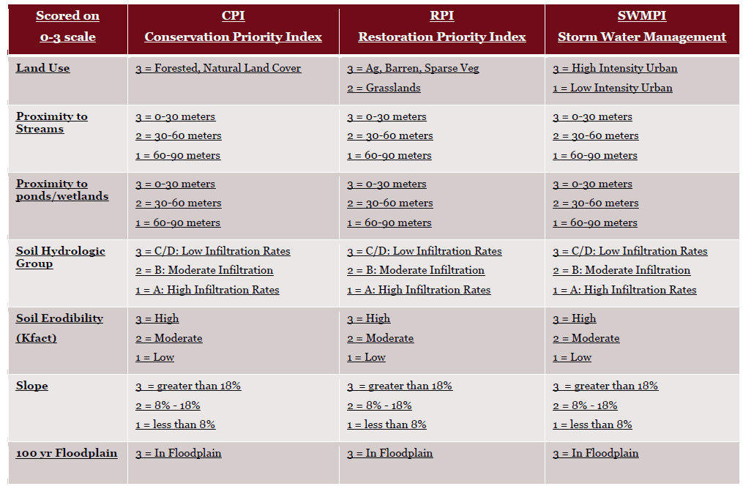

Table A-1: The factors and weightings of the WMPI and sub-modules.

Soil Hydrologic Group: Soil hydrologic group describes water infiltration performance of unvegetated soils subject to long-duration rainfall. For all sub-basin counties except Screven County, GA, soil hydrologic group was extracted from the digital Soil Survey Geographic (SSURGO) by the United States Department of Agriculture's Natural Resources Conservation Service using the NRCS Soil Data Viewer 6.0 extension for ArcGIS. Screven County currently lacks SSURGO data. State Soil Geographic (STATSGO) data was substituted here, and hydrologic groups were manually assigned by comparing STATSGO unit descriptions to the dominant SSURGO-level units that compose each STATSGO group. Soils with hybrid assignments were grouped according to the most restrictive element (ie. an A/D soil was treated as Group D). Soils were then scored according to Table A-1, and output as a continuous raster.

Soil Erodibility Factor (K): Soil erodibility is the propensity of a soil to erode when exposed to rainfall. For all sub-basin counties except Screven County, GA, soil erodibility was extracted from the digital Soil Survey Geographic (SSURGO) by the United States Department of Agriculture's Natural Resources Conservation Service using the NRCS Soil Data Viewer 6.0 extension for ArcGIS. Screven County currently lacks SSURGO data. State Soil Geographic (STATSGO) data was substituted here, and erodibility was manually assigned by comparing STATSGO unit descriptions to the dominant SSURGO-level units that compose each STATSGO group. The full range of soil erodibility (0.26 to 0.74) was then split into three equal groups (0.26-0.42; 0.42 to 0.58; 0.58 to 0.74) and assigned scores 1, 2, or 3 respectively.

Slope: Slope was derived from the 30 meter digital elevation model (DEM); US Geological Survey National Elevation Data of September 2010. As our analysis is focused on the lower sub-basin, the slope ranges given by the WMPI framework were not descriptive of the sub-basin. We addressed this by identifying the range of slopes present in the analysis area, and dividing them into three equal ranges (0-4%; 5-8%; 9-12%). The ranges were assigned scores 1, 2, or 3 respectively.

100-Year Floodplain: Typical 100-year floodplain mapping was available for only limited areas of the project. We developed the Active River Area (ARA) model as a substitute, assigned all material collection zones identified in ARA as floodplain, and scored those areas as 3. The ARA uses cost-distance analysis of conditions upslope from streams to identify the meander belt within a 30m DEM. Flow accumulation areas are then identified by co-location of known and historic wetlands with low slope (<2%) areas. Material collection areas not captured by the first two steps are identified with 30 meters of headwater streams using the SLICE method (ESRI, 2006). Verifications against FEMA 100-year floodplain mapping show that ARA produces 65-90% agreement with FEMA mapping. Full ARA method documentation is found at <http://water.epa.gov/polwaste/nps/watershed/landscape_condition.cfm> . Visual inspection of the ARA output for the lower Savannah sub-basin showed good agreement with known stream and floodplain corridors.

**Completing the CPI**

Once all CPI layers were complete, each layer was visually reviewed for accuracy. No significant processing or alignment issues were found at this stage. The seven layers were then overlaid using the Weighted Sum function in Spatial Analyst 10.0 to produce the map shown as Figure 6 in the main text. Total sum scores for individual pixels range from 5 to 21.

**Tract Priority Analysis**

The original CPI is very illustrative in depicting land – water quality relationships at the 30x30m pixel level. To transform the CPI to a useful tool for targeted conservation real estate transactions, CPI pixel scores were accumulated inside of legal tract boundaries and divided by acreage to produce a single tract score. Digital tract boundary data was acquired through online County GIS data portals, and through the national tract database maintained by CoreLogic, Inc., a major real estate analysis and tracking firm in San Jose, CA. Dates of tract data acquisition range from January 2010 through October, 2013. Tract data was unattainable for two partial counties in the project area (Jenkins County, GA and Saluda County, SC), omitting 12,333 and 23,875 acres respectively from the tract analysis (1.3% of the project area).

The Zonal Statistics function was used to accumulate CPI scores inside of tract boundaries. The accumulated scores were then divided by tract acreage to create an overall tract score. A map of these scored tracts is shown as Figure 7 in the main text. The calculation produced a range of tract scores from 5-16. To aid the use of tract-accumulated CPI scores in program development and implementation, we culled out tracts below 100 acres (total of 389,593 acres), and assigned four score ranges as Priorities 1 through 4 using a Jenks classification of natural breaks. The top range contains four values (11-14) as opposed to two for all other ranges, as there is a very small number of tracts scoring 13 or 14. Tracts scoring 15 or 16 were all under 100 acres. Table A-2 details the results.

|  |  |  |  |
| --- | --- | --- | --- |
| **Acreage Distribution by Tract-Accumulated CPI Priority (> 100 acres)** | | | |
| *Tract CPI Score Range* | *Priority Level* | *Protected Acres* | *Unprotected Acres* |
| 11-14 | Priority 1 | 44,787 | 117,923 |
| 9-10 | Priority 2 | 75,201 | 340,401 |
| 7-8 | Priority 3 | 132,285 | 952,336 |
| 5-6 | Priority 4 | 249,727 | 284,137 |

Table A-2: Acreage of lands by CPI priority. Total acreage is less than the project area due to the 100-acre filter.

The selection of a 100-acre filter was driven by implementation feasibility. Tract size does not affect the amount of personnel or resources needed to execute a land protection transaction. Thus, a large tract can be protected just as easily as a small one, creating a better return on investment per transaction.

If all Priority 1 and 2 tracts were protected and added to current protected lands, the lower Savannah River sub-basin would be 34.4% protected basin-wide (960,324 of 2,789,463 total acres), and 43.7% protected with respect to all tracts over 100 acres (960,324 of 2,196,797 total acres).

We recognize an inherent bias in resolving the CPI to the tract level with an areal denominator. Very large tracts have diluted scores due to the large areal basis of the calculation. Very small tracts falling on high scoring areas have inflated scores. However, the bias appears to introduce minimal error for all but the very largest tracts (the ~200,000 acre Savannah River Site, SC, and ~56,000 acre Fort Gordon, GA), which are essentially protected now. The locations of the highest tract scores are consistent with the locations of highest CPI scores.

**APPENDIX B: Southeast GAP Land Cover Assignments**

|  |  |  |  |  |  |
| --- | --- | --- | --- | --- | --- |
|  | **Application of Southeast GAP Land Cover Assignments** |  | Used In? | | |
| VALUE | NAME | CODE | LU % | Nat. LC | Wet |
| 1 | Open Water (Fresh) | SEGAP111 | Yes | No | Yes |
| 2 | Open Water (Brackish/Salt) | SEGAP112 | Yes | No | No |
| 4 | Developed Open Space | SEGAP211 | Yes | No | No |
| 5 | Low Intensity Developed | SEGAP220 | Yes | No | No |
| 6 | Medium Intensity Developed | SEGAP230 | Yes | No | No |
| 7 | High Intensity Developed | SEGAP240 | Yes | No | No |
| 16 | Bare Sand | SEGAP311 | Yes | No | No |
| 17 | Bare Soil | SEGAP312 | Yes | No | No |
| 18 | Quarry/Strip Mine/Gravel Pit | SEGAP313 | Yes | No | No |
| 33 | Southern Piedmont Granite Flatrock | CES202.329 | Yes | Yes | No |
| 35 | Unconsolidated Shore (Lake/River/Pond) | SEGAP321 | Yes | Yes | Yes |
| 36 | Unconsolidated Shore (Beach/Dune) | SEGAP322 | Yes | Yes | Yes |
| 37 | Deciduous Plantations | SEGAP410 | Yes | Yes | No |
| 39 | Atlantic Coastal Plain Dry and Dry-Mesic Oak Forest | CES203.241 | Yes | Yes | No |
| 40 | Atlantic Coastal Plain Mesic Hardwood and Mixed Forest | CES203.242 | Yes | Yes | No |
| 57 | Southern Coastal Plain Dry Upland Hardwood Forest | CES203.560 | Yes | Yes | No |
| 61 | Atlantic Coastal Plain Fall-line Sandhills Longleaf Pine Woodland - Offsite Hardwood Modifier | CES203.254d | Yes | Yes | No |
| 64 | Atlantic Coastal Plain Xeric River Dune | CES203.497 | Yes | Yes | No |
| 66 | Southern Piedmont Dry Oak-(Pine) Forest - Hardwood Modifier | CES202.339a | Yes | Yes | No |
| 68 | Southern Piedmont Mesic Forest | CES202.342 | Yes | Yes | No |
| 70 | Northern Atlantic Coastal Plain Dry Hardwood Forest | CES203.475 | Yes | Yes | No |
| 71 | Evergreen Plantations or Managed Pine (can include dense successional regrowth) | SEGAP420 | Yes | Yes | No |
| 72 | Atlantic Coastal Plain Central Maritime Forest | CES203.261 | Yes | Yes | No |
| 73 | Atlantic Coastal Plain Northern Maritime Forest | CES203.302 | Yes | Yes | No |
| 74 | Atlantic Coastal Plain Southern Maritime Forest | CES203.537 | Yes | Yes | No |
| 86 | Southern Piedmont Dry Oak-(Pine) Forest - Loblolly Pine Modifier | CES202.339b | Yes | Yes | No |
| 87 | Southern Piedmont Dry Oak-Heath Forest - Virginia/Pitch Pine Modifier | CES202.023b | Yes | Yes | No |
| 90 | Atlantic Coastal Plain Fall-Line Sandhills Longleaf Pine Woodland - Loblolly Modifier | CES203.254c | Yes | Yes | No |
| 91 | Atlantic Coastal Plain Fall-line Sandhills Longleaf Pine Woodland - Open Understory Modifier | CES203.254a | Yes | Yes | No |
| 92 | Atlantic Coastal Plain Fall-line Sandhills Longleaf Pine Woodland - Shrub Understory Modifier | CES203.254b | Yes | Yes | No |
| 93 | Atlantic Coastal Plain Upland Longleaf Pine Woodland | CES203.281 | Yes | Yes | No |
| 99 | Southern Coastal Plain Oak Dome and Hammock | CES203.494 | Yes | Yes | No |
| 100 | Southeastern Interior Longleaf Pine Woodland | CES202.319 | Yes | Yes | No |
| 108 | Southern Piedmont Dry Oak-(Pine) Forest - Mixed Modifier | CES202.339c | Yes | Yes | No |
| 109 | Southern Piedmont Dry Oak-Heath Forest - Mixed Modifier | CES202.023c | Yes | Yes | No |
| 119 | Southern Piedmont Glade and Barrens | CES202.328 | Yes | Yes | No |
| 125 | Successional Shrub/Scrub (Clear Cut) | SEGAP511 | Yes | Yes | No |
| 126 | Successional Shrub/Scrub (Utility Swath) | SEGAP512 | Yes | Yes | No |
| 127 | Successional Shrub/Scrub (Other) | SEGAP513 | Yes | Yes | No |
| 141 | Atlantic Coastal Plain Northern Dune and Maritime Grassland | CES203.264 | Yes | Yes | No |
| 142 | Atlantic Coastal Plain Southern Dune and Maritime Grassland | CES203.273 | Yes | Yes | No |
| 145 | Clearcut - Grassland/Herbaceous | SEGAP710 | Yes | Yes | No |
| 146 | Other - Herbaceous | SEGAP720 | Yes | Yes | No |
| 147 | Utility Swath - Herbaceous | SEGAP730 | Yes | Yes | No |
| 148 | Pasture/Hay | SEGAP810 | Yes | Yes | No |
| 149 | Row Crop | SEGAP820 | Yes | No | No |
| 151 | Atlantic Coastal Plain Blackwater Stream Floodplain Forest - Forest Modifier | CES203.247a | Yes | Yes | Yes |
| 152 | Atlantic Coastal Plain Brownwater Stream Floodplain Forest | CES203.248 | Yes | Yes | Yes |
| 153 | Atlantic Coastal Plain Small Blackwater River Floodplain Forest | CES203.249 | Yes | Yes | Yes |
| 154 | Atlantic Coastal Plain Small Brownwater River Floodplain Forest | CES203.250 | Yes | Yes | Yes |
| 164 | Southern Piedmont Large Floodplain Forest - Forest Modifier | CES202.324a | Yes | Yes | Yes |
| 165 | Southern Piedmont Small Floodplain and Riparian Forest | CES202.323 | Yes | Yes | Yes |
| 167 | Atlantic Coastal Plain Nonriverine Swamp and Wet Hardwood Forest - Taxodium/Nyssa Modifier | CES203.304b | Yes | Yes | Yes |
| 168 | Atlantic Coastal Plain Nonriverine Swamp and Wet Hardwood Forest - Oak Dominated Modifier | CES203.304a | Yes | Yes | Yes |
| 173 | Atlantic Coastal Plain Clay-Based Carolina Bay Forested Wetland | CES203.245a | Yes | Yes | Yes |
| 174 | Atlantic Coastal Plain Northern Basin Swamp and Wet Hardwood Forest | CES203.520 | Yes | Yes | Yes |
| 175 | Atlantic Coastal Plain Peatland Pocosin | CES203.267 | Yes | Yes | Yes |
| 176 | Atlantic Coastal Plain Streamhead Seepage Swamp, Pocosin, and Baygall | CES203.252 | Yes | Yes | Yes |
| 179 | Southern Coastal Plain Nonriverine Basin Swamp | CES203.384 | Yes | Yes | Yes |
| 180 | Southern Coastal Plain Seepage Swamp and Baygall | CES203.505 | Yes | Yes | Yes |
| 182 | Southern Piedmont/Ridge and Valley Upland Depression Swamp | CES202.336 | Yes | Yes | Yes |
| 184 | Atlantic Coastal Plain Southern Wet Pine Savanna and Flatwoods | CES203.536 | Yes | Yes | Yes |
| 194 | Southern Coastal Plain Hydric Hammock | CES203.501 | Yes | Yes | Yes |
| 195 | Southern Coastal Plain Nonriverine Cypress Dome | CES203.251 | Yes | Yes | Yes |
| 204 | Atlantic Coastal Plain Northern Tidal Wooded Swamp | CES203.282 | Yes | Yes | Yes |
| 205 | Atlantic Coastal Plain Southern Tidal Wooded Swamp | CES203.240 | Yes | Yes | Yes |
| 213 | Atlantic Coastal Plain Central Fresh-Oligohaline Tidal Marsh | CES203.376 | Yes | Yes | Yes |
| 215 | Atlantic Coastal Plain Northern Fresh and Oligohaline Tidal Marsh | CES203.516 | Yes | Yes | Yes |
| 217 | Atlantic and Gulf Coastal Plain Interdunal Wetland | CES203.258 | Yes | Yes | Yes |
| 218 | Atlantic Coastal Plain Depression Pondshore | CES203.262 | Yes | Yes | Yes |
| 225 | Atlantic Coastal Plain Clay-Based Carolina Bay Herbaceous Wetland | CES203.245b | Yes | Yes | Yes |
| 231 | Southern Coastal Plain Herbaceous Seepage Bog | CES203.078 | Yes | Yes | Yes |
| 245 | Atlantic Coastal Plain Central Salt and Brackish Tidal Marsh | CES203.270 | Yes | Yes | No |
| 248 | Atlantic Coastal Plain Northern Tidal Salt Marsh | CES203.519 | Yes | Yes | No |

VALUE: A numerical value assigned to the habitat type by SE GAP

NAME: The name of the habitat type

CODE: The specific code within the International Vegetation Classification system (CES*) or SE GAP descriptions (SEGAP*)

LU%: Habitat was used (“yes”) in the calculation of lower Savannah River sub-basin land use percentages

Nat LC: Habitat was used (“yes”) in Forested Natural Land Cover factor of the Conservation Priority Index (CPI)

Wet: Habitat was used (“yes”) in creation of wetland distance-to layer of the CPI

**Appendix C: Mixed Land Use Watershed Examples**

The following section highlights four recent studies that examined water quality in mixed forested and agricultural watersheds. These snapshots capture both successes and challenges of attributing changes in water quality to changes in land use distribution from upstream to downstream, or by comparing tributary watersheds that differ from each other primarily by land use distribution.

*Little River, Georgia*

For the Savannah River, the best example for mixed land use and water quality response at a watershed scale is the Little River Experimental Watershed near Tifton in south-central GA. This 82,500-acre sub-watershed of the Suwannee River was subject to long-term weekly water quality monitoring, stream gauging and load analyses, modeling, socioeconomic analysis, and landowner outreach to understand factors of conservation practice selection and maintenance (Meals, et al., 2011). Land use is 41% agriculture (row crop 31%; pasture 10%), 50% forest, 7% urban, and 2% open water. Primary products on row crop areas are currently cotton (60% of cropland), peanuts (38%), and corn (2%). Natural riparian forest buffers are the dominant conservation practice, though 47 practices in all have been deployed. Forest buffers were implemented voluntarily and not cost-supported. The most extensive practices on production lands include nutrient management, pest management, grassed waterways, contour farming, tillage / residue management, and terraces. By 2006, 57% of agricultural lands had some conservation practice installed through the NRCS.

Analysis of water quality data in Little River and tributaries shows low instream nutrient loads, with 1-2% of applied nitrogen reaching streams. This is less than atmospheric deposition levels. Total phosphorous is declining, and dissolved oxygen is increasing (Feyereisen et al. 2007; Todd et al. 2009, 2010). Modeling of the existing buffer network indicates sediment reductions of 75%, a finding that comports with low observed P (P typically attaches to sediments) (Cho et al. 2010). In general, modeled and field results demonstrate that 1) buffers perform critical nutrient and sediment trapping (46-foot buffer average) 2) nutrient management is an important adjunct practice, responsible for 32% and 21% of N and P capture (Cho et al. 2010).

Meals et al. (2011) also suggest that the 50% balance of forested land use in the watershed is a significant contributor to the success of managed agricultural practice in improving water quality in the Little River.

*Upper Oconee River, Georgia*

Fisher and others (2000) analyzed agricultural and urban impacts at eighteen (18) sites in the 1.87M acre Upper Oconee River watershed in Georgia upstream of the city of Athens, GA. Upstream sub-watersheds contained poultry house and cattle operations producing over 64 million broilers and 55,000 beef cattle per year. Agricultural clearing in analyzed sub-watersheds ranged from 20-31%. Nutrients and fecal coliform were elevated near farm operations, but dissipated downstream prior to reaching the municipal intake for Athens. Samples were also taken immediately above and below the city of Athens. The passage of the River through the city of Athens doubled nutrient loads, and produced a slight increase in fecal coliforms. In summary, concentrated animal agriculture produced distinct, but very localized nutrient and bacterial effects. A reference sampling site on the undeveloped Apalachee River produced consistently lower turbidity, nutrient, and bacteria levels than the other 17 sites.

*Coweeta Creek, North Carolina*

Bolstad and Swank (1997) demonstrated downstream increases in turbidity, fecal coliform and streptococcus counts, and nitrate with increased downstream agricultural and suburban development in Coweeta Creek, North Carolina. Suburban and agricultural land use extent at downstream sampling points was small and relatively even (~4% each, with 92-94% of the balance in forest). Increased contamination was most pronounced during storm events. Overland flow was more pronounced in developed areas, delivering more contamination per unit land area. Percent non-forest, structure density, and paved road density were the best correlates of turbidity and fecal counts, suggesting that suburbanized areas were more effective in translating contamination to streams.

*Lake Champlain, New York and Vermont*

Meals and Budd (1998) examined land use and non-point phosphorous (P) relationships in the 2.0M-acre Lake Champlain basin, which was 62% forest, 28% agriculture, 7% open water, and 3% urban at the time of the study. Agriculture contributed 66% of the total P load, compared to 18% for urban land and 16% for forest. However, when converted to per area bases, urban lands delivered much more P, followed by agriculture and forest. The authors conclude that both agricultural and urban management strategies are important for controlling non-point source pollutants. The authors also noted the lack of livestock exclusion from streams in BMP programs at the time, and implicated this omission as a likely source of continued P exports. Meals (2001) followed with analyses on sub-watershed areas that received streambank fencing, riparian plantings, reinforced cattle crossings, and designated watering station treatments as best management practices to reduce livestock impacts. The treated sub-watershed showed 25% total P reduction, 42% reduced P export, and 46-52% reduction in bacterial load despite occurrence of major storm runoff events during the 5-year study period. The improved results are very consistent with the Little River (GA) example, demonstrating the efficacy of upland and riparian BMPs used in combination.